Advance Payment Interface Specification

Low Level Design Document

EIDIKO SYSTEMS INTEGRATORS



Contents
1. Introduction 4
1.1 General Description 4
2. Purpose 4
3. Scope 4
3.1 In Scope 4
4. Channels Involved 4
5. Interface Dependencies 5
5.1 External Dependencies 5
5.2 Internal Dependencies 5
6. Business Process Summary 5
6.1 Process Overview: 5
6.1.1 advancePayment Steps 6
7. ACE Implementation Process Flow 6
7.1HTTPS Router Process Flow 6
7.1.1 Process Flow Steps: 6
7.1.2 Incoming Router Process Flow Diagram: 7
7.1.3 Outgoing Router Process Flow Steps: 7
7.1.4 Outgoing Router Process Flow Diagram 8
7.2 advancePaymentAPI Request Response Flow 8
7.2.1 Process Flow Steps 8
7.2.2Process Diagram 9
7.2.3 Process Flow Steps: 10
7.3 Audit_Logging Process Flow 10
7.3.1 Process Flow Steps: 10
7.4 Error_Audit Process Flow 11
7.4.1 Process Flow Steps: 11
7.4.2 Process Flow Diagram 11
8. Interface Definitions 11
8.1 Request Message Definition 11
8.1.1 Channel Request Message Structure/Schema to ESB 11
8.1.2 Channel Request Message Details to ESB 11
8.1.3 Channel Sample Source Messages to ESB. 12
8.1.4 ESB Request Message Structure/Schema to Backend 14
8.1.5 ESB Request Message Details to Backend 14
8.1.6 ESB Sample Source Messages to Backend 15
8.1.7 Application Error Codes 16
8.1.8 Sample Error Response to Channel 16
8.2 Response Message Definition 18
8.2.1 Backend Response Message Structure/Schema to ESB 18
8.2.2 Backend Response Message Details to ESB 18
8.2.3 Backend Sample Response Messages to ESB 21
8.2.4 ESB Response Message Details to Channel. 25
8.2.5 ESB Sample Response Messages to Channel. 26
9. Logging Mechanism 27
9.1 Insert into AUDIT_LOGGING_Table 27
9.2 Insert into ERROR_LOGGING 27
9.3 Insert into SERVICE_MAPPER Table 28
10. Database Details 29

Introduction

1.1 General Description
This Interface Design document outlines the integration requirements for the advancePayment(Request and Response) interface used as banking operations. It summarizes the business processes, which use this interface. It also covers error handling and exception scenarios.

Purpose
The purpose of this document is to capture events that trigger the interface, main steps within the interface and the integration architecture. This document is intended for use by the developers of the applications identified, the integration development team, and by the test organizations responsible for the testing of these applications.

Scope

3.1 In Scope
This document focuseson outlining the interface design for theadvancePayment(Request and Response) interface. Central to this document are the following:
- Overview of the business process that drives the need for the interface
- Proposed integration approach
- Trigger events and business dependencies on this interface
- Sequence /Flow Chart diagram of the interface
- Data mapping between the source and the target
- Error handling and exception scenarios
- Validation and backup requirements

Channels Involved
The following list of channels will be using advancePayment. This service can be adopted with the same message structure by any new channel if Bank wants to on board in future

Item # | Channel Name
1 | Netplus

Interface Dependencies

5.1 External Dependencies

The following table lists interface specific External requirements.
Item # | External Requirements
1 | SQL Database
2 | Core Banking System – Temenos (T24)

5.2 Internal Dependencies

The following table lists interface specific internal requirements.
Item # | Internal Requirements
1 | HTTPS Router Interface (Gateway) – HttpsGatewayApp
2 | CommonLibrary (Shared Library)
3 | ExceptionHandler (Shared Library)
4 | userDefined(Policy Project)

6. Business Process Summary

6.1 Process Overview:

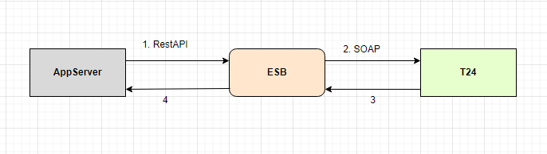

Figure: 1 Process flow Approach for advancePayment

6.1.1 advancePayment Steps

S. No | Activities
1 | ESB receives the request from HTTPRouter in JSON Format.
2 | Request channel is the https request accepts the request from the Router.
3 | ESB frames the request according to the T24 required format(i.e SOAP) and sends it to T24. So, ESB will do the transformation from JSON to SOAP.
4 | T24 will respond back to the ESB, with a Response in SOAP Format
5 | The same T24 Response, ESB will send back to the Channel in JSON Format.  So, ESB will do the transformation from SOAP to JSON.
6 | On a Successful transaction, the Channel Request, ChannelResponse along with application request and response will be placed in the Database table (AUDIT_LOGGING);
7 | On an Unsuccessful Transaction, the exception details are placed in the Database Table (ERROR_LOGGING).

ACE Implementation Process Flow

7.1HTTPS Router Process Flow

7.1.1 Process Flow Steps:

S. No | ACE receives the request from channel.
1 | ESB receives the request from channel (Source System).
2 | HTTPS protocol will accept the request from the channel.
3 | According to the Channel Request header fields such as based upon X-Request-ID, Servicecode (valAmtOnAdvpymt | processAmtOnAdvpymt) message will be routed on business application.
4 | It validates the X-Request-ID, Servicecode headers present in requested message.If it fails, the error is logged in the logs and in Database (ERROR_LOGGING)
5 | If it is success or failure response will store them in AUDIT_LOGGING table or ERROR_LOGGING and log into the table.
6 | The request from the channel is sent to ESB advancePaymentAPI Flow

7.1.2 Incoming Router Process Flow Diagram:
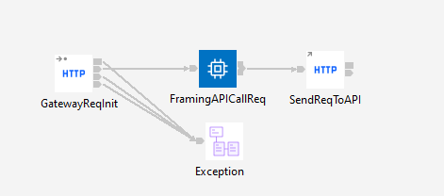
Figure: 2 Incoming Router Flow

7.1.3 Outgoing Router Process Flow Steps:
S. No | Activities
1 | The OutgoingHttpsRes flow sends the Channel Response
2 | Channel Response will be logged in AUDIT_LOGGING table.
3 | Finally, Channel Response will be sent to the Front End.

7.1.4 Outgoing Router Process Flow Diagram
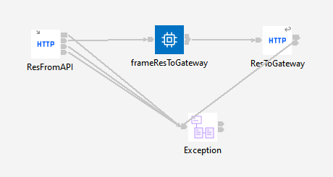

Figure:3 Outgoing Router Flow

advancePaymentAPI Request Response Flow

7.2.1 Process Flow Steps

S. No | Activities
1 | ESB receives the request from the channel (AppServer) in JSON Format and ESB expects HTTPS headers X-Request-ID, Servicecode through the HTTPS Router Flow. Based on the serviceCode(valAmtOnAdvpymt | processAmtOnAdvpymt) the request routes to the respective Business Application (advancePaymentAPI).
2 | Initial request is logged in either Database Table (AUDIT_LOGGING) or Console or on both. The decision to log on either database table or console or both can be decided by SERVICE_MAPPER Table.
3 | After logging of request, JSON Message will be mapped to SOAP Message i.e T24 Request will be Framed.
4 | ESB will Fetch the Username, Password. Company from the User-defined policy and frames the Request in SOAP Format to back-end server i.e T24 server
5 | After Framing the T24 Request, it is logged in the Database Table (AUDIT_LOGGING) or Console or on both.
6 | If the T24 call is successful, then Response will generate in SOAP Format.
7 | T24 Response in SOAP Format is logged in the Database Table (AUDIT_LOGGING) or Console or on both.
8 | SOAP Response is mapped to JSON format; it will be sent back to Channel through the HTTPS Router Flow.
9 | Channel Response in JSON Format is logged in the Database Table (AUDIT_LOGGING) or Console or on both.
10 | On Un successful Transaction the Exception details are logged in the Database Table (ERROR_LOGGING).

7.2.2Process Diagram

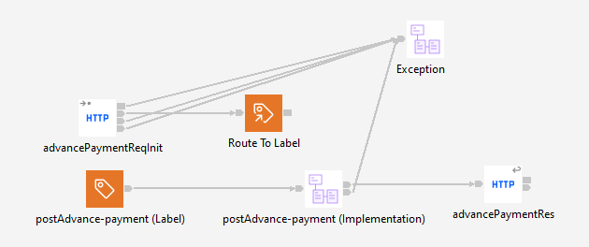

Figure: 4Advance Payment Flow

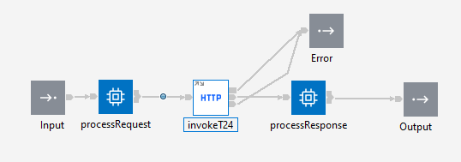
Figure: 5 Advance Payment Flow

7.2.3 Process Flow Steps:
Following table lists fields need to be mapped in preparation of core banking request by accessing userDefined (Policy project).
Sl.No | DB Field Name | Field Description | Data Type
1 | USERNAME | User Name | character
2 | PASSWORD | Password | character
3 | COMPANY | Company | character

Audit_Logging Process Flow

7.3.1 Process Flow Steps:
S. No | Activities
1 | The common library will log the input Request and Response. AUDIT_PROCEDURE from common library logs data on database.
2 | After the query is executed, the record is inserted into the Database (AUDIT_LOGGING).

Error_Audit Process Flow

7.4.1 Process Flow Steps:
S. No | Activities
1 | To call the ERROR_LOGGING_PROC. Then store error logs.
2 | After the procedure will be executed the record is inserted into the Database.

7.4.2 Process Flow Diagram

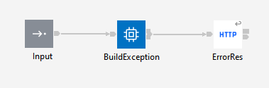
Figure:6 Exception Sub flow

Interface Definitions

8.1 Request Message Definition

8.1.1 Channel Request Message Structure/Schema to ESB
Request Type: HTTPS
Request Format: JSON
Request Method: POST
RequestURL: https://<ipadress>:<portNumber>/esbgateway/api/v1/customers/transactions/advance-payment/

8.1.2 Channel Request Message Details to ESB

Item # | HTTPSheaderfields | Data Type | Mandatory(Yes/No) | Comments
1 | ServiceCode | String | Y | Service Code
2 | X-Request-ID | String | Y | It is a Unique Identifier for each message.

Item # | Tag Name/ Field Name | Data Type | Mandatory(Yes/No) | Comments
1 | clientTransactionId | String | Y | The channel/system that triggered the transaction
2 | transactionType | String | Y | Credit card account number
3 | creditCardAccount | String | Y | Credit Card Account
4 | Amount | Number | Y | Transaction amount
5 | requestDate | String | Y | The transaction value date
6 | debitAccount | String | Y | DebitAccountNumber
7 | Channel | String | Y | A Channel
8 | username | String | Y | Username
9 | description | String | Y | Description

8.1.3 Channel Sample Source Messages to ESB.

8.1.3.1 Testing the Advance Payment API using Postman
The following image illustrates the process of testing the Advance Payment API using the Postman tool. Ensure that the four key segments are correctly configured in Postman as shown in the image:
Method: Select the appropriate HTTPS method (POST) for the API request.
URL: Provide the full API endpoint URL to which the request should be sent.
Headers: Include X-Request-Id, Servicecode (processAmtOnAdvpymt | valAmtOnAdvpymt).
Body: Specify the request body, formatted as JSON data format. 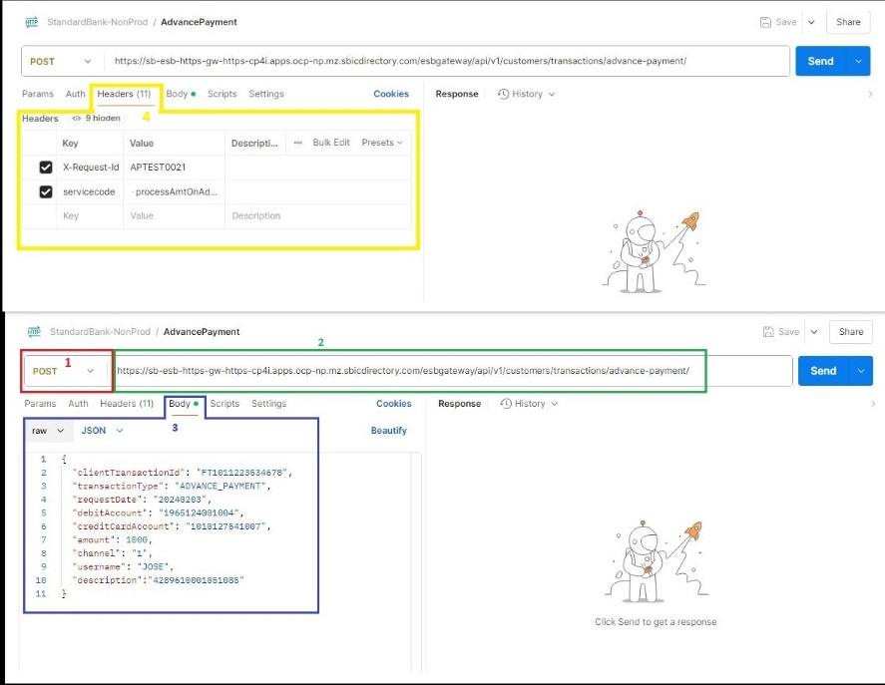

8.1.3.2 Sample request Body
{
"clientTransactionId": "FT1011223534678",
"transactionType": "ADVANCE_PAYMENT",
"requestDate": "20240203",
"debitAccount": "1965124001004",
"creditCardAccount": "1010127541007",
"amount": 1000,
"channel": "1",
"username": "JOSE",
"description":"4289610001051085"
}

8.1.4 ESB Request Message Structure/Schema to Backend
Request Type: SOAP
Request Format: JSON
Request URL: http://<ipaddress>:<portnumber> /CMS-SERVICES/services

8.1.5 ESB Request Message Details to Backend

Item # | Tag Name/ Field Name | Data Type | Mandatory (Yes/No) | Comments
1 | Header | String | Y | Header Tag
2 | Body | String | Y | Body Tag
3 | SBGenericTransferandPayments | String | Y | Root Tag
4 | WebRequestCommon | String | Y | WebRequestCommon Tag
5 | company | String | Y | company
6 | Password | String | Y | Password
7 | Username | String | Y | username
8 | OfsFunction | String | Y | OfsFunction
9 | FUNDSTRANSFERSBMPAYMENTAPI100Type | String | Y | Root Tag
10 | DEBITACCTNO | String | Y | Debit Account number
11 | DEBITTHEIRREF | String | Y | DetbittheirRef
12 | gPAYMENTDETAILS | String | Y | Root Tag
13 | PAYMENTDETAILS | String | Y | Payment Details
14 | SBCHANNEL | String | Y | SB channel
15 | NETTXNID | String | Y | Net Transaction Id
16 | REQUESTDATE | String | Y | Request Date
 | NETUSERNAME | String | Y | Net User Name
 | LSOURCETYPE | String | Y | LSourceType
 | LBUSINESSIND | String | Y | LBusinessIndicator

8.1.6 ESB Sample Source Messages to Backend

ReleaseFund SampleT24 Request:
<soapenv:Envelopexmlns:soapenv="http://schemas.xmlsoap.org/soap/envelope/"
xmlns:cms="http://temenos.com/CMS-SERVICES"
xmlns:fun="http://temenos.com/FUNDSTRANSFERSBMPAYMENTAPI100">
<soapenv:Header/>
<soapenv:Body>
<cms:SBGenericTransferandPayments>
<WebRequestCommon>
<company>MZ0010101</company>
<password>123456</password>
<userName>ENQUIRYUSER01</userName>
</WebRequestCommon>
<OfsFunction>
</OfsFunction>
<FUNDSTRANSFERSBMPAYMENTAPI100Type id="">
<fun:OPERATION>VALIDATE</fun:OPERATION>
<fun:DEBITACCTNO>1010127541007</fun:DEBITACCTNO>
<fun:DEBITTHEIRREF>Advanced Payment</fun:DEBITTHEIRREF>
<fun:CREDITAMOUNT>100</fun:CREDITAMOUNT>
<fun:gPAYMENTDETAILS g="1">
<fun:PAYMENTDETAILS>4289610001051085</fun:PAYMENTDETAILS>
</fun:gPAYMENTDETAILS>
<fun:SBCHANNEL>1</fun:SBCHANNEL>
<fun:NETTXNID>54353</fun:NETTXNID>
<fun:REQUESTDATE>20240411</fun:REQUESTDATE>
<fun:NETUSERNAME>JOSE</fun:NETUSERNAME>
<fun:LSOURCETYPE>ACM</fun:LSOURCETYPE>
<fun:LBUSINESSIND>ADVANCEDPAYMENT</fun:LBUSINESSIND>
</FUNDSTRANSFERSBMPAYMENTAPI100Type>
</cms:SBGenericTransferandPayments>
</soapenv:Body>
</soapenv:Envelope>

8.1.7 Application Error Codes
Application Error Codes | Error Type | Actual Description
404 | Failure | Resource Not Found
500 |  | Internal Server Error
503 |  | Service Unavailable
400 |  | Bad Request

8.1.8 Sample Error Response to Channel

404 – Resource Not Found:
{
"statusCode": 404,
"timestamp": "2024-03-03T08:41:32.253688572",
"title": "Resource Not Found",
"details": "We were not able to find the resource you were looking for. Resource may have been moved or never existed.",
"path": "/resource-path"
}

500 Internal Server Error:
{
"statusCode": 500,
"timestamp": "2024-03-03T08:41:32.253688572",
"title": "T24 Error",
"details": "Unfortunately, an internal server error prevented us from proceeding with your request. Try again later.",
"path": "/resource-path"
}

503 Service Unavailable:

{
"statusCode": 503,
"timestamp": "2024-03-03T08:41:32.253688572",
"title": "Service Unavailable",
"details": "Unfortunately, the service you requested for is currently unavailable. Try again later”
"path": "/resource-path"
}

400 Bad Request:
{
"statusCode": 400,
"timestamp": "2024-03-03T08:41:32.253688572",
"title": "Form validation errors",
"requestId": "1234567890",
"details": "The submitted data contains or more form errors",
"path": "/resource",
"fields": [
{
"field": "fieldName",
"message": "Description of the field error"
}
]
}

8.2 Response Message Definition

8.2.1 Backend Response Message Structure/Schema to ESB
Response Type: SOAP

8.2.2 Backend Response Message Details to ESB

Item # | Tag Name/Field Name | Data Type | Mandatory(Yes/No) | Comments
1 | Header | String | Y | Header Tag
2 | Body | String | Y | Body Tag
3 | SBGenericTransferandPaymentsResponse | String | Y | Root tag
4 | Status | String | Y | Status Tag
5 | transactionId | String | Y | Transaction ID
6 | messageId | String | Y | Message ID
7 | successIndicator | String | Y | successIndicator
8 | Application | String | Y | Application Name
9 | FUNDSTRANSFERType | String | Y | FUNDSTRANSFERType
10 | TRANSACTIONTYPE | String | Y | TRANSACTIONTYPE
11 | DEBITACCTNO | String | Y | DEBITACCTNO
12 | CURRENCYMKTDR | String | Y | CURRENCYMKTDR
13 | DEBITCURRENCY | String | Y | DEBITCURRENCY
14 | DEBITVALUEDATE | String | Y | DEBITVALUEDATE
15 | DEBITTHEIRREF | String | Y | DEBITTHEIRREF
16 | CREDITTHEIRREF | String | Y | CREDITTHEIRREF
17 | CREDITACCTNO | String | Y | CREDITACCTNO
18 | CURRENCYMKTCR | String | N | CURRENCYMKTCR
19 | CREDITCURRENCY | String | Y | CREDITCURRENCY
20 | CREDITAMOUNT | String | Y | CREDITAMOUNT
21 | CREDITVALUEDATE | String | Y | CREDITVALUEDATE
22 | PROCESSINGDATE | String | Y | PROCESSINGDATE
23 | gORDERINGBANK | String | N | gORDERINGBANK root tag
24 | ORDERINGBANK | String | N | ORDERINGBANK
25 | gPAYMENTDETAILS | String | Y | gPAYMENTDETAILS root tag
26 | PAYMENTDETAILS | String | Y | PAYMENTDETAILS
27 | CHARGESACCTNO | String | N | CHARGESACCTNO
28 | CHARGECOMDISPLAY | String | N | CHARGECOMDISPLAY
29 | COMMISSIONCODE | String | N | COMMISSIONCODE
30 | CHARGECODE | String | N | CHARGECODE
31 | PROFITCENTREDEPT | String | N | PROFITCENTREDEPT
32 | RETURNTODEPT | String | N | RETURNTODEPT
33 | FEDFUNDS | String | N | FEDFUNDS
34 | POSITIONTYPE | String | N | POSITIONTYPE
35 | AMOUNTDEBITED | String | Y | AMOUNTDEBITED
36 | AMOUNTCREDITED | String | Y | AMOUNTCREDITED
37 | CREDITCOMPCODE | String | N | CREDITCOMPCODE
38 | DEBITCOMPCODE | String | N | DEBITCOMPCODE
39 | LOCAMTDEBITED | String | N | LOCAMTDEBITED
40 | LOCAMTCREDITED | String | N | LOCAMTCREDITED
41 | CUSTGROUPLEVEL | String | N | CUSTGROUPLEVEL
42 | DEBITCUSTOMER | String | N | DEBITCUSTOMER
43 | CREDITCUSTOMER | String | N | CREDITCUSTOMER
44 | DRADVICEREQDYN | String | N | DRADVICEREQDYN
45 | CRADVICEREQDYN | String | N | CRADVICEREQDYN
46 | CHARGEDCUSTOMER | String | N | CHARGEDCUSTOMER
47 | TOTRECCOMM | String | N | TOTRECCOMM
48 | TOTRECCOMMLCL | String | N | TOTRECCOMMLCL
49 | TOTRECCHG | String | N | TOTRECCHG
50 | TOTRECCHGLCL | String | N | TOTRECCHGLCL
51 | RATEFIXING | String | N | RATEFIXING
52 | TOTRECCHGCRCCY | String | N | TOTRECCHGCRCCY
53 | TOTSNDCHGCRCCY | String | N | TOTSNDCHGCRCCY
54 | gSTMTNOS | String | N | gSTMTNOS root tag
55 | STMTNOS | String | N | STMTNOS
56 | gOVERRIDE | String | N | gOVERRIDE root tag
57 | OVERRIDE | String | N | OVERRIDE
58 | RECORDSTATUS | String | N | RECORDSTATUS
59 | CURRNO | String | N | CURRNO
60 | gINPUTTER | String | N | gINPUTTER root tag
61 | INPUTTER | String | N | INPUTTER
62 | gDATETIME | String | N | gDATETIME root tag
63 | DATETIME | String | Y | DATETIME
64 | AUTHORISER | String | N | AUTHORISER
65 | COCODE | String | N | COCODE
66 | DEPTCODE | String | N | DEPTCODE
67 | INPUTVERSION | String | N | INPUTVERSION
68 | DBACCTNAME | String | N | DBACCTNAME
69 | CRACCTNAME | String | N | CRACCTNAME
70 | SBCHANNEL | String | Y | SBCHANNEL
71 | NETTXNID | String | Y | NETTXNID
72 | REQUESTDATE | String | Y | REQUESTDATE
73 | NETUSERNAME | String | Y | NETUSERNAME
74 | SBUETRID | String |  | SBUETRID
75 | LSOURCETYPE | String | Y | LSOURCETYPE
76 | LBUSINESSIND | String | N | LBUSINESSIND

8.2.3 Backend Sample Response Messages to ESB

<S:Envelopexmlns:S="http://schemas.xmlsoap.org/soap/envelope/">
<S:Body>
<ns9:SBGenericTransferandPaymentsResponse xmlns:ns2="http://temenos.com/ACLOCKEDEVENTS" xmlns:ns3="http://temenos.com/SBGETACCTNET" xmlns:ns4="http://temenos.com/EBACMCREDITCARD" xmlns:ns5="http://temenos.com/SBGETCUSTOMER" xmlns:ns6="http://temenos.com/FUNDSTRANSFERSBMPAYMENTAPI100" xmlns:ns7="http://temenos.com/FUNDSTRANSFER" xmlns:ns8="http://temenos.com/SBGETENETTXNDTX" xmlns:ns9="http://temenos.com/CMS-SERVICES">
<Status>
<transactionId>FT2320671641</transactionId>
<messageId>TWS241171040058635.00</messageId>
<successIndicator>Success</successIndicator>
<application>FUNDS.TRANSFER</application>
</Status>
<FUNDSTRANSFERType id="FT2320671641">
<ns7:TRANSACTIONTYPE>ACKP</ns7:TRANSACTIONTYPE>
<ns7:DEBITACCTNO>1010127541007</ns7:DEBITACCTNO>
<ns7:CURRENCYMKTDR>1</ns7:CURRENCYMKTDR>
<ns7:DEBITCURRENCY>MZN</ns7:DEBITCURRENCY>
<ns7:DEBITVALUEDATE>20230725</ns7:DEBITVALUEDATE>
<ns7:DEBITTHEIRREF>Advanced Payment</ns7:DEBITTHEIRREF>
<ns7:CREDITTHEIRREF>P</ns7:CREDITTHEIRREF>
<ns7:CREDITACCTNO>1965124001004</ns7:CREDITACCTNO>
<ns7:CURRENCYMKTCR>1</ns7:CURRENCYMKTCR>
<ns7:CREDITCURRENCY>MZN</ns7:CREDITCURRENCY>
<ns7:CREDITAMOUNT>100.00</ns7:CREDITAMOUNT>
<ns7:CREDITVALUEDATE>20230725</ns7:CREDITVALUEDATE>
<ns7:PROCESSINGDATE>20230725</ns7:PROCESSINGDATE>
<ns7:gORDERINGBANK>
<ns7:ORDERINGBANK>STANDARD BANK</ns7:ORDERINGBANK>
</ns7:gORDERINGBANK>
<ns7:gPAYMENTDETAILS>
<ns7:PAYMENTDETAILS>4289610001051085</ns7:PAYMENTDETAILS>
</ns7:gPAYMENTDETAILS>
<ns7:CHARGESACCTNO>1010127541007</ns7:CHARGESACCTNO>
<ns7:CHARGECOMDISPLAY>NO</ns7:CHARGECOMDISPLAY>
<ns7:COMMISSIONCODE>DEBIT PLUS CHARGES</ns7:COMMISSIONCODE>
<ns7:CHARGECODE>DEBIT PLUS CHARGES</ns7:CHARGECODE>
<ns7:PROFITCENTREDEPT>1900</ns7:PROFITCENTREDEPT>
<ns7:RETURNTODEPT>NO</ns7:RETURNTODEPT>
<ns7:FEDFUNDS>NO</ns7:FEDFUNDS>
<ns7:POSITIONTYPE>TR</ns7:POSITIONTYPE>
<ns7:AMOUNTDEBITED>MZN100.00</ns7:AMOUNTDEBITED>
<ns7:AMOUNTCREDITED>MZN100.00</ns7:AMOUNTCREDITED>
<ns7:CREDITCOMPCODE>MZ0010196</ns7:CREDITCOMPCODE>
<ns7:DEBITCOMPCODE>MZ0010101</ns7:DEBITCOMPCODE>
<ns7:LOCAMTDEBITED>100.00</ns7:LOCAMTDEBITED>
<ns7:LOCAMTCREDITED>100.00</ns7:LOCAMTCREDITED>
<ns7:CUSTGROUPLEVEL>99</ns7:CUSTGROUPLEVEL>
<ns7:DEBITCUSTOMER>12081</ns7:DEBITCUSTOMER>
<ns7:CREDITCUSTOMER>90000</ns7:CREDITCUSTOMER>
<ns7:DRADVICEREQDYN>N</ns7:DRADVICEREQDYN>
<ns7:CRADVICEREQDYN>N</ns7:CRADVICEREQDYN>
<ns7:CHARGEDCUSTOMER>12081</ns7:CHARGEDCUSTOMER>
<ns7:TOTRECCOMM>0</ns7:TOTRECCOMM>
<ns7:TOTRECCOMMLCL>0</ns7:TOTRECCOMMLCL>
<ns7:TOTRECCHG>0</ns7:TOTRECCHG>
<ns7:TOTRECCHGLCL>0</ns7:TOTRECCHGLCL>
<ns7:RATEFIXING>NO</ns7:RATEFIXING>
<ns7:TOTRECCHGCRCCY>0</ns7:TOTRECCHGCRCCY>
<ns7:TOTSNDCHGCRCCY>0.00</ns7:TOTSNDCHGCRCCY>
<ns7:gSTMTNOS>
<ns7:STMTNOS>VAL</ns7:STMTNOS>
</ns7:gSTMTNOS>
<ns7:gOVERRIDE>
<ns7:OVERRIDE>ACCT.UNAUTH.OD}Unauthorised overdraft of && on account &.{MZN}949331.76}1010127541007{MZN{949331.76{1010127541007{12081{982{{*U60</ns7:OVERRIDE>
</ns7:gOVERRIDE>
<ns7:RECORDSTATUS>INAO</ns7:RECORDSTATUS>
<ns7:CURRNO>1</ns7:CURRNO>
<ns7:gINPUTTER>
<ns7:INPUTTER>10400_ENQUIRYUSER1__WS___OFS_TWS</ns7:INPUTTER>
</ns7:gINPUTTER>
<ns7:gDATETIME>
<ns7:DATETIME>2404261617</ns7:DATETIME>
</ns7:gDATETIME>
<ns7:AUTHORISER>10400_ENQUIRYUSER1</ns7:AUTHORISER>
<ns7:COCODE>MZ0010101</ns7:COCODE>
<ns7:DEPTCODE>1900</ns7:DEPTCODE>
<ns7:INPUTVERSION>FUNDS.TRANSFER,SBM.PAYMENT.API.1.0.0</ns7:INPUTVERSION>
<ns7:DBACCTNAME>AURELIO ANTONIO NUNES ROCHA</ns7:DBACCTNAME>
<ns7:CRACCTNAME>VISA SETTLEMENT AND CLEARANCE</ns7:CRACCTNAME>
<ns7:SBCHANNEL>1</ns7:SBCHANNEL>
<ns7:NETTXNID>54353</ns7:NETTXNID>
<ns7:REQUESTDATE>20240411</ns7:REQUESTDATE>
<ns7:NETUSERNAME>JOSE</ns7:NETUSERNAME>
<ns7:SBUETRID>3df4f0a8-0ba8-4d43-a7c1-e79080a72554</ns7:SBUETRID>
<ns7:LSOURCETYPE>ACM</ns7:LSOURCETYPE>
<ns7:LBUSINESSIND>ADVANCEDPAYMENT</ns7:LBUSINESSIND>
</FUNDSTRANSFERType>
</ns9:SBGenericTransferandPaymentsResponse>
</S:Body>
</S:Envelope>

8.2.4 ESB Response Message Details to Channel.

Item # | Tag Name/Field Name | Data Type | Mandatory(Yes/No) | Comments
1 | statusCode | String | Y | Status code.
2 | message | String | Y | Message details.
3 | data | String | Y | Root tag
4 | clientTransactionId | String | Y | Client Transaction Id
5 | transactionType | String | Y | Transaction Type
6 | creditAccount | String | Y | account
7 | creditCardAccount | String | Y | Credit Card Account
8 | valueDate | String | Y | Value Date
9 | requestDate | String | Y | Processed At
10 | amount | Number | Y | Transaction amount
11 | currency | String | Y | currency
12 | channel | String | Y | channel
13 | username | String | Y | username
14 | description | String | Y | Description

8.2.5 ESB Sample Response Messages to Channel.
{
"statusCode": 200,
"message": "Operation performed successfully",
"data": {
"transactionId": "FT2420604907",
"clientTransactionId": "FT23206716415",
"transactionType": "ADVANCE_PAYMENT ",
"debitAccount": "XXXXXXXXXXXXXX",
"creditCardAccount": "4289610001051085",
"valueDate": "20240724",
"requestDate": "20240724",
"amount": "100.00",
"currency": "MZN",
"channel": "1",
"username": "JOSE",
"description": "4289610001051085"
}
}

Logging Mechanism

9.1 Insert into AUDIT_LOGGING_Table
Table Name: AUDIT_LOGGING
Item # | DB Field Name | Field Description | Data Type | Length | Mandatory (Yes/No) | Comments
1 | requestId | UniqueueMessageID | Varchar | 50 | Y | From input request
2 | LOGGING_TIME | Logging Time | Varchar | 50 | Y | Name
3 | MESSAGE | Message (Request/Response) | Clob | - | Y | Request from channel
4 | MESSAGETYPE | Type of Message (Request/Response) | Varchar | 50 | Y | Type of message either Request or Response
5 | APPNAME | Application Name | Varchar | 50 | Y | Name of the Application
6 | FLOWNAME | Message flow name | Varchar | 50 | Y | Message flow name
7 | SRVCODE | Service code | Varchar | 50 | Y | Service code.

Insert into ERROR_LOGGING

Table Name: ERROR_LOGGING
Item # |  | DB Field Name |  | Field Description |  | Data Type |  | Length |  | Mandatory(Yes/No) |  | Comments
1 | requestId |  | UniqueueMessageID |  | Varchar |  | 50 |  | Y |  | From input request
2 | LOGGING_TIME |  | Application Name |  | Timestamp |  | 50 |  | Y |  | Time of the logging
3 | MESSAGE |  | Message Type(Request/Response) |  | Clob |  | 50 |  | Y |  | Request of the Message
4 | MESSAGETYPE |  | Message Type |  | Varchar |  | 50 |  | Y |  | Type of message either Request or Response
5 | APPNAME |  | Application Name |  | Varchar2 |  | 4000 |  | Y |  | Name of the Application
6 | ERRORDESCRIPTION |  | Error description |  | clob |  | - |  | Y |  | Error description
7 | FLOWNAME |  | Message flow name |  | Varchar2 |  | 50 |  | Y |  | Message flow name
8 | SRVCODE |  | Service code |  | Varchar2 |  | 50 |  | Y |  | Service code

Insert into SERVICE_MAPPER Table
Table Name: SERVICE_MAPPER
Item # |  | DB Field Name |  | Field Description | Data Type |  | Length |  | Mandatory(Yes/No) | Comments
1 | SERVICECODE |  | Uniqueue string identifies each service |  | Varchar | 50 |  | Y |  |  | From input request
2 | URL |  | Business flow url value |  | Varchar | 300 |  | Y |  |  | Unique resource locator of business application
3 | DBLOGGINGFLAG |  | A character value |  | Varchar | 50 |  | Y |  |  | Flag to define logging
4 | CONSOLELOGFLAG |  | A character value |  | Varchar | 50 |  | Y |  |  | Flag to define logging

Database Details
Following details need to be used while creating Data Source Name (DSN) and in a connection to database.
Item | value
Database Name | SQLSERVER
DSN Name | SQLSERVER
IP address | 10.245.87.110
Schema Name | IBMACEDEV.dbo
User name | IBMACEDEVUSR
Password | _z4ntzOq_z4ntzOqIBMACEDEV

